P09

Query Panel For Central Fraud Registry

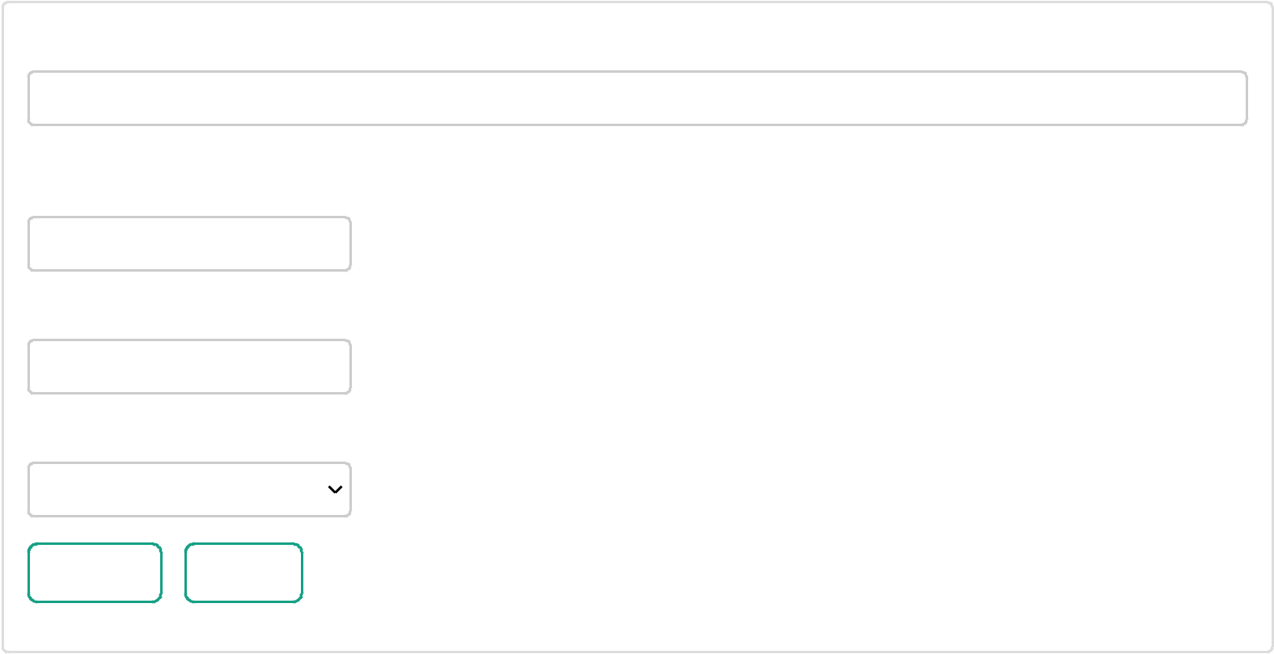

Party/ Account Name or Associate Concern Name

Mr. MAKHAN LAL SAHU

Enter atleast three letters of Party/ Account Name/ PAN and select from the list

Reporting Date From

01/04/2016

To

10/10/2024

Amount Involved

All Fraud

Search Reset

Please note that :

The choice of at least one among 'Party/ Account or Associate Concern Name' and 'Reporting Date' is

MANDATORY.

The auto-search option in 'Party/ Account or Associate Concern Name' field only shows first 100 rows.

